We all by now know what generative AI does.. it generates audio, codes, images and whatnot. They are essentially sophisticated.
Agentic AI Systems by contrast are not reactive (unlike generative AI) but proactive. Course of action for agentic ai.. perceive -> decide -> execute -> learn

Agentic AI is multi step process here we are using GenAI’s ability to kind of think. And it has a name called CoT (Chain of Thought) Reasoning. Where a complex problem is broken down into smaller logical steps.
Example for Organizing a conference, it will generate an internal dialogue.
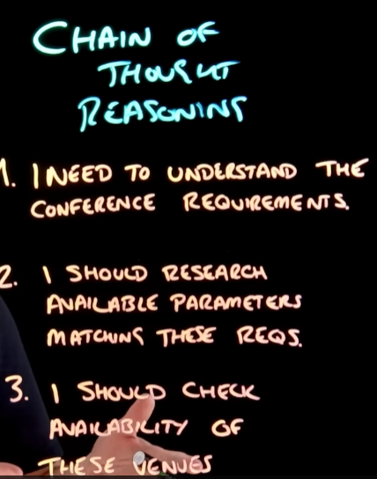
So basically… Generative AI makes memes. Agentic AI books your dentist appointment.

